**Course Code: 032207009**

**Data structures and algorithms Summers 2022**

**Pharmacy Management System**

**Project Report By**

**Group leader: Atib Ur Rehman**

**Group Members:**

Atib Ur Rehman 16417

Hamza Salahuddin 11111

Sufyan Azhar 11111

**Table of Contents**

1. Introduction 3

2. Scope 3

3. Module Description 3

4. Hardware/Software Requirements 3

5. Screen Shots 3

# Introduction

The main aim of the project is the management of the database of the pharmaceutical shop. This project is insight into the design and implementation of a Pharmacy Management System. This is done by creating a database of the available medicines in the shop and information of customers and employees. The primary aim of pharmacy management system is to improve accuracy and enhance safety and efficiency in the pharmaceutical store. The aim of this project is to develop software for the effective management of a pharmaceutical store. We have developed this software for ensuring effective policing by providing statistics of the drugs in stock. The database is then connected to the main program by using interconnection of the Java Netbeans program and the database already created in Microsoft Access. Pharmacy management system is useful to maintain correct database by providing an option to update the drugs in stock. This is pharmacy management system; it is used to manage most pharmacy related activities in the pharmacy.

# Scope

At present, manual system is being utilized in the pharmacy. It requires the pharmacist to manually monitor each drug that is available in the pharmacy. Pharmacy management has kept paper record in filing cabinets. Managing a very large pharmacy with records on papers will be tedious and difficult to keep track of inventories with regards to the drugs in the store, expiry date, quantity of drugs available based on the categories and their functions. This implies that these services will be manually completed by the pharmacist. This usually leads to mistakes as the workload of the pharmacist increases. This system also ensures that there exists a level of restricted access based on functionality and role. This system also provides optimal drug inventory management by monitoring the drug movement in the pharmacy. Significant amount of time is allocated for writing the order as the pharmacist needs to go through the stock balance and make rough estimate of the amount to order based on Figures. The system will not be able to handle drug prescription, drug to drug interaction.

# Module Description

This module includes different packages created with netbeans ide which includes different packages , Java swing j frames forms and classes.

Class paths:

6 files are used to complete the class path connecting ODBC database with netbeans.

Data Structures:

Data structures we used in this program are doubly linked list and circular queue.

Algorithms:

One binary searching algorithm is used to retrieve the existing customers data.

# 4. Hardware/Software Requirements

* Operating system : Windows 7 based system
* Database : Microsoft Access (Using ucanaccess)
* Language : Java
* Processor : Intel Core 2 Duo or up
* Ram : 1GB or up
* Hard disk : 5GB or up for better result

# 5. Screen Shots

First interface:

Usernames and passwords are saved in database for employee login while admin and admin default password can be used to access admin panel.

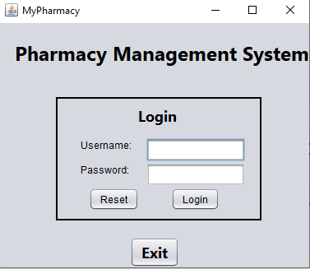

Employees interface:

This interface is for employee use, where medicines can be selected to sell.

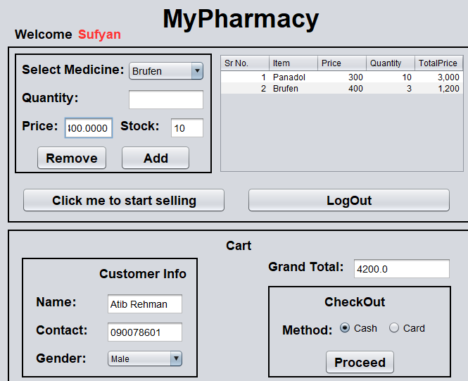

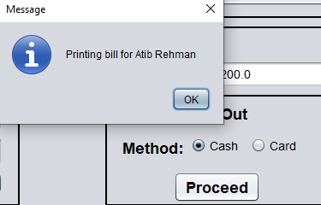

Admin interface:

It has two options, both allows to edit the details where we can add, remove and update items and access database as well.

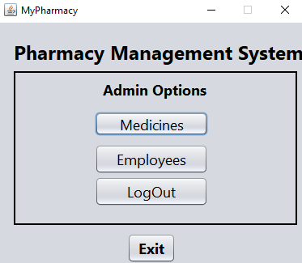

EditEmployees interface:

This interface has multiple options, Add new employees will add the details in doubly linked list and shows it on the first (Upper) JTable. The details we add in our linked list we can use to add them on database by clicking them. On click it will get into the selected items where we can use the option of add to database.

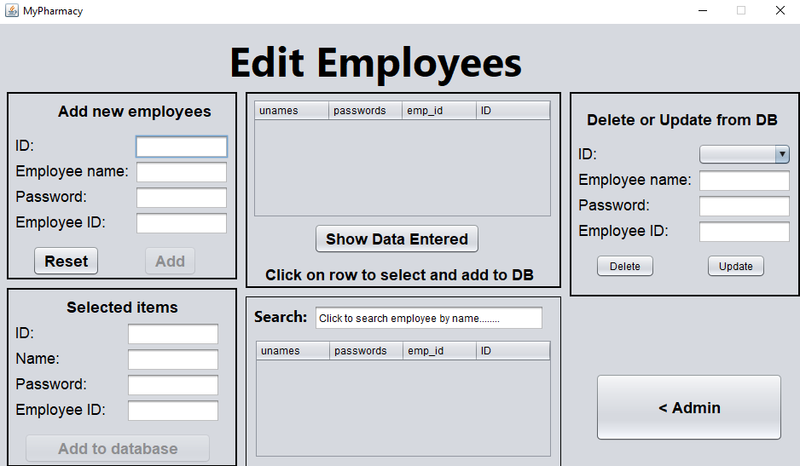

Adding new user:

1)

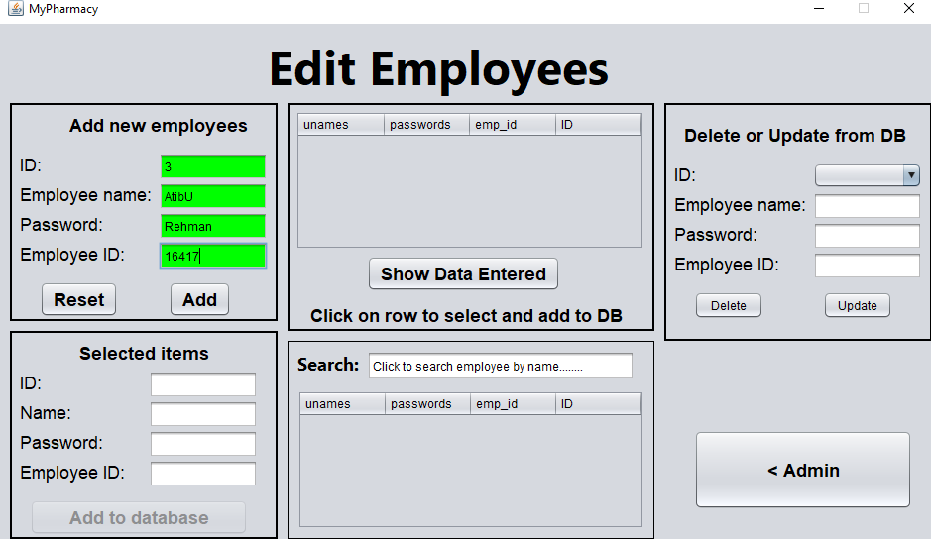

2)

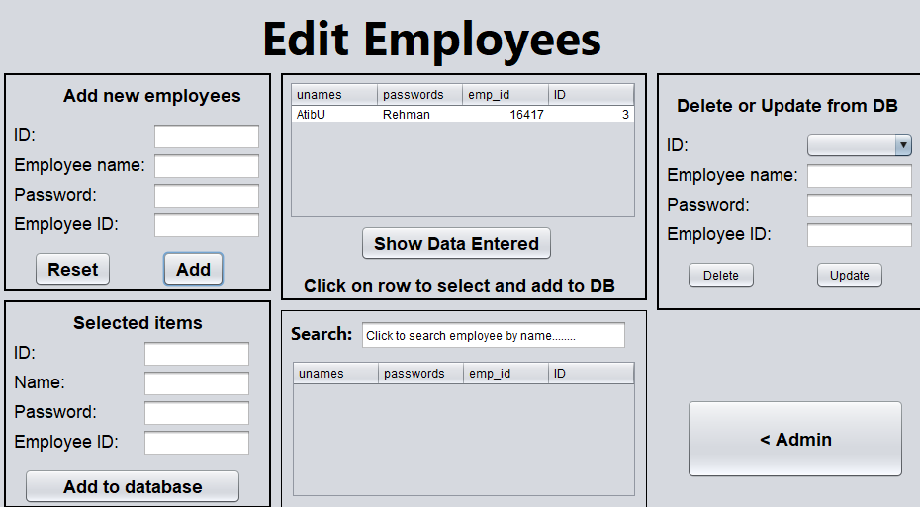

3)

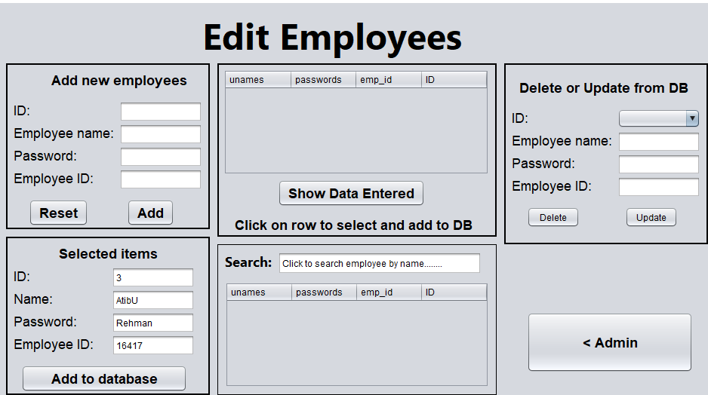

4)

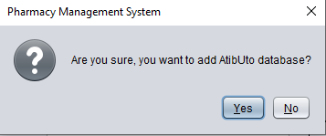

Search by Name:

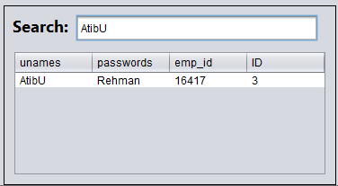

Delete or update user:

On mouse enter it will fetch all the data from database:

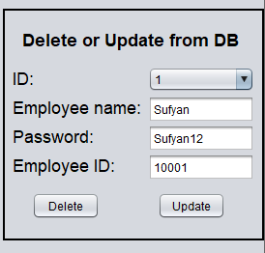

Deleting:

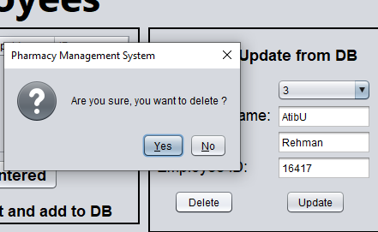

Updating:

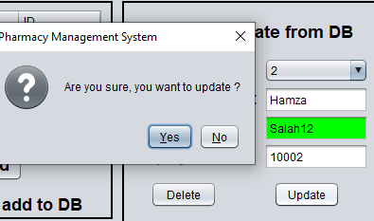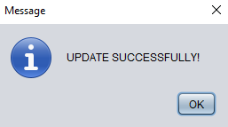

All same functionalities are with EditMedicine..